# CALENDAR MANAGEMENT SYSTEM

PROJECT REPORT SUBMITTED BY

**JOMIN K MATHEW**

**TKM20MCA2021**

TO

THE APJ ABDUL KALAM TECHNOLOGICAL UNIVERSITY

IN PARTIAL FULFILLMENT OF THE REQUIRMENTS FOR THE AWARD OF THE DEGREE

OF

# MASTER OF COMPUTER APPLICATION



**THANGAL KUNJU MUSIALIAR COLLEGE OF ENGINEERING**

# KERALA

MARCH 2022

**DECLARATION**

I undersigned hereby declare that the mini project report “**CALENDAR MANAGEMENT SYSTEM**”, submitted for partial fulfilment of the requirements for the award of degree of Master of Computer Applications of the APJ Abdul Kalam Technological University, Kerala is a bonafide work done by me under supervision of **Prof. VAHEETHA SALAM**. This submission represents my ideas in my own words and where ideas or words of others have been included, I have adequately and accurately cited and referenced the original sources. I also declare that I have adhered to ethics of academic honesty and integrity and have not misrepresented or fabricated any data or idea or fact or source in the submission. I understand that any violation of the above will be a cause for disciplinary action by the institute and/or the University and can also evoke penal action from the sources which have thus not been properly cited or from whom proper permission has not been obtained. This report has not been previously formed the basis for the award of any degree, diploma or similar title of any other University.

KOLLAM JOMIN K MATHEW

05/03/2022

# THANGAL KUNJU MUSIALIAR COLLEGE OF ENGINEERING

**DEPARTMENT OF COMPUTER APPLICATION**



# CERTIFICATE

This is to certify that, this report entitled **“CALENDAR MANAGEMENT SYSTEM”** is a bonafide record of the work submitted by **JOMIN K MATHEW (TKM20MCA-2021**), under our guidance and supervision, in partial fulfilment of the requirements for the award of the Degree of Master of Computer Applications in APJ Abdul Kalam Technological University. This report in any form has not been submitted to any other University or Institute for any purpose.

Internal Supervisor Mini Project Coordinator

# 

# ACKNOWLEDGEMENT

First and foremost, I thank GOD almighty and our parents for the success of this project. I owe sincere gratitude and heart full thanks to everyone who shared their precious time and knowledge for the successful completion of our project.

I am extremely grateful to **Dr. NADERA BEEVI S**, Head of the Department, Dept. of Computer Applications, for providing us with best facilities.

I would like to place on record my sincere gratitude to my external project guide **KRISHNAN BHAGAVATH** and internal guide **Prof. VAHEETHA SALAM**, Associate Professor, Dept. of Computer Applications for the guidance and mentorship throughout the course.

I profusely thank all other faculty members in the department and all other members of TKM College of Engineering, for their guidance and inspirations throughout my course of study.

I owe thanks to my friends and all others who have directly or indirectly helped me in the successful completion of this project.

**JOMIN K MATHEW**

# ABSTRACT

In an era where everyone is eager to do more and achieve even more, the software category of “Online Calendar” has caught the fancy of business owners and employees alike. This technology solution has made way for productivity and real time sharing by compressing the time devoted to planning and allocating of resources. Trust this wonderful software as your personal digital assistant to address varied needs like time management, appointment scheduling, team planning, managing meetings and invitations. With this Calendar Management System, the user can quickly schedule meetings and events. Although the calendar defaults to showing users event times in their local time, users can specify a different time zone for an event, so the user always know what’s next. Calendar is designed for teams, so it’s easy to share the schedule with others and create multiple calendars that the user and his team can use together

# CONTENTS

## INTRODUCTION 1

* 1. OBJECTIVE 1

## LITERATURE SURVEY 2

1. **METHODOLOGY 3**
   1. PROPOSED SYSTEM 4
   2. TECHNOLOGIES USED 4
      1. REACTJS 4
      2. POSTGRESQL 5
      3. SPRING BOOT 6
      4. GOOGLE CALENDAR API 7
   3. WORKING OF MODULES 8
2. **RESULT AND DISCUSSION 10**
   1. OUTPUTS 11
3. **CONCLUSION 13**
   1. FUTURE ENHANCEMENT 13
4. **REFERENCES 14**

# CHAPTER 1

## INTRODUCTION

Calendar management is the systematic process of organizing meetings, events, and tasks with the ultimate goal of maximizing the return on investment you can get from the precious limited resource we call time. A well-managed centralized calendar system ensures a strategic, efficient, and effective allocation of time. Getting this right lays the foundation for capturing many other business benefits, namely achievement, efficiency, organization, collaboration, and insight. A well-managed calendar should reflect and enable core priorities.

Sure, nowadays every smartphone comes with a simple calendar app you can use, but for serious businesses, using such an app is not really a viable option. Use of a centralized system gives the opportunity to users to accumulate all the events scheduled in various calendars. It helps them to easily remember and can join in events at proper time .It also avoid occurrence of multiple events at same time by notifying it to corresponding organizers. Organizations can easily identify the availability of group members and reschedule meetings according to the convenience. Each member in organization can see others events.

## OBJECTIVE

The user can login to a user interface which is build using REACT JS and from that interface he/she can see all scheduled events which includes name , date ,starting time and end time

.Thus it helps user to get all the events without looking through various calendars assigned to them .Thus the project aims to create a system which helps the user to save his/her time and shows accessibility of user which help others to schedule/reschedule events and ensures participation and collaboration of every one in corresponding event which is essential for the success of and event/meeting.

Key Features are:

* + - Time saving
    - User friendly
    - It gathers information from various calendar apis
    - Easily accessible for each person in organization
    - Ensures collaboration of each member in an organization

# CHAPTER 2

## LITERATURE SURVEY

In the past few years, many researchers have been working on the development cross- platform to integrate all the projects to a single web page where we can easily look into. Some related works are:

This paper is an extension of the work in [1] in which we presented a system of using soft constraints, as well as a heuristic method to schedule events and re-optimize. However, this method was still very computationally intensive, which is what this paper addresses. Also, as stated in [1], there are no similar models to compare so we will revisit those most relevant.

The patent [2] presents a method in which events are scheduled based on the optimization of variables. The variables represent real world factors such as Location, Equipment, and Attendants. On any given day and time-slot, a variable is given a binary value (available or not available) to represent its availability. Variables can be given a set of constraints that can vary. For example, locations having a preference and attendants being mandatory, these variables can be categorized as preferred and optional, respectively. The scheduler tries to find the day and time such that the availability value is maximized across variables.

The patent [3] attempts to solve the problem of having the user continually manage their schedule. It attempts to do this in several ways, one of which is a combination of variables. One such variable is similar to what was presented in [1], by the use of priority level or importance score. However, while [1] tries to optimize across all persons, [3] focuses on a particular users schedule.

The patent [4] gives the user the ability to insert flexible events. A user can specify a flexible event by giving a duration for the event (how long it lasts) and a time period in which the event can be moved around. The user can also specify a minimum blocking time. This is the minimum duration in which the flexible event can be split. This is used when there are no contiguous time-slots available within the period that fits the flexible events duration.

In the patent [5], they optimize event scheduling by trying to learn/capture the users preferences. Their work can be described in three phases, a proper model to capture specific user preferences, a proper learning technique, and a reasoning/ranking system which can select the best schedule generated.

[6] is a mainstream solution to event scheduling using the traditional approach of hard constraints. The patent [7] is also traditional, however, given the similar constraints (dates, attendees, and times ), it presents a list of candidate times. In the case that no candidate times can be generated, it allows for the relaxation of constraints.

The patents [8] and [9] are similar to [6]. However, [8] introduces a best fit approach which can suggest another time given extremely low attendance or find another slot for users with a higher attendance priority. [9] reutilizes the concept of best fit, however it expands its framework from users to resources meaning resource availability can be accounted for in much the same way as attendees.

Finally, patent [10] uses a traditional system. However it accommodates re-scheduling with the use of actions. The actions include shortening of meetings or finding another time-slot. Users give penalty values for actions, the scheduler then attempts to find a solution while minimizing the overall penalty score.

# CHAPTER 3

# METHODOLOGY

* 1. **PROPOSED SYSTEM**

In Existing System it provides about schedule meetings or events and get reminders about upcoming activities through email and calendar notification.

In Proposed System we are generally managing a Centralized Calendar system for all platforms and displaying other user’s calendar. Based on this we can schedule the meeting or events

The key Features are

* Time saving.
* User friendly.
* It gathers information from various calendar API’s.
* Easily accessible for each person in organization. Ensures collaboration of each member in an organization.

Here we gather information from respective API and store it in PostgreSQL database and used spring boot as backend. User interface is built using React JS and it will display all the events scheduled in various calendar API.

## TECHNOLOGIES USED

## REACTJS

ReactJS is one of the most popular JavaScript front-end libraries which has a strong foundation and a large community. ReactJS is a declarative, efficient, and flexible JavaScript library for building reusable UI components. It is an open-source, component-based front end library which is responsible only for the view layer of the application. The main objective of ReactJS is to develop User Interfaces (UI) that improves the speed of the apps. It uses virtual DOM (JavaScript object), which improves the performance of the app. The JavaScript virtual DOM is faster than the regular DOM. We can use ReactJS on the client and server-side as well as with other frameworks. It uses component and data patterns that improve readability and helps to maintain larger apps

The salient features of React library are as follows −

* Extensible architecture
* Component based library
* JSX based design architecture
* Declarative UI library Benefits

Few benefits of using React library are as follows −

* Easy to learn
* Easy to adapt in modern as well as legacy application
* Faster way to code a functionality
* Availability of large number of ready-made component
* Large and active community

## POSTGRESQL

PostgreSQL is an advanced, enterprise class open source relational database that supports both SQL (relational) and JSON (non-relational) querying. It is a highly stable database management system, backed by more than 20 years of community development which has contributed to its high levels of resilience, integrity, and correctness. PostgreSQL is used as the primary data store or data warehouse for many web, mobile, geospatial, and analytics applications. The latest major version is PostgreSQL 12.

PostgreSQL has a rich history for support of advanced data types, and supports a level of performance optimization that is common across its commercial database counterparts, like Oracle and SQL Server. AWS supports PostgreSQL through a fully managed database service with Amazon Relational Database Service (RDS). Amazon Aurora with PostgreSQL compatibility is also built using PostgreSQL.

Importance of PostgreSQL:

* Stores data securely.
* Supports best practices,
* Allows retrieving the data when the request is processed.
* Is cross-platform and can run on many operating systems including Linux, FreeBSD, OS X, Solaris, and Microsoft Windows.

Benefits:

* Open Source DBMS
* Supports both SQL (relational) and JSON (non-relational) querying.
* Stable
* High Integrity, and Correctness.

## SPRING BOOT

Java Spring Framework (Spring Framework) is a popular, open source, enterprise-level framework for creating standalone, production-grade applications that run on the Java Virtual Machine (JVM).

Java Spring Boot (Spring Boot) is a tool that makes developing web application and micro services with Spring Framework faster and easier through three core capabilities:

1. Auto configuration
2. An opinionated approach to configuration
3. The ability to create standalone applications

Spring Boot provides a good platform for Java developers to develop a stand-alone and production-grade spring application that you can just run. You can get started with minimum configurations without the need for an entire spring configuration setup.

Spring Boot offers the following advantages to its developers −

* Easy to understand and develop spring applications
* Increases productivity
* Reduces the development time

Spring Boot is designed with the following goals −

* To avoid complex XML configuration in Spring
* To develop a production ready Spring applications in an easier way
* To reduce the development time and run the application independently
* Offer an easier way of getting started with the application

Features and benefits:

* It provides a flexible way to configure Java Beans, XML configurations, and Database Transactions.
* It provides a powerful batch processing and manages REST endpoints.
* In Spring Boot, everything is auto configured; no manual configurations are needed.
* It offers annotation-based spring application
* Eases dependency management
* It includes Embedded Servlet Container

## GOOGLE CALENDAR API

Google Calendar API is an easiest way to add your Google calendar into your application and manipulate your events and organize meetings, synchronization of calendar in various devices. Here, I will give a basic idea about Google Calendar API with JavaScript. For example, you could develop a web application to create or display Calendar data, or a desktop application that synchronizes a user's Calendar with an existing desktop application. Your app could be a device that brings the Calendar experience to a new platform.

The Google Calendar API enables developers to add full calendar data and functionality into their app using a REST interface, or through [one of the client libraries Google offers](https://developers.google.com/calendar/overview#quickstarts) for languages like Java, Python, PHP, JavaScript, and more.

Google Calendar allows client applications to view and update calendar events in the form of Google data API. Your client application can use the Google Calendar data API to create new events, edit or delete existing events, and query for events that match particular criteria.

There are many possible uses for the Calendar data API. For example, you can create a web front end for your group's calendar that uses Google Calendar as a back end. Or you can generate a public calendar for Google Calendar to display or you can search relevant calendars to display a list of upcoming events on those calendars.

## WORKING OF MODULES

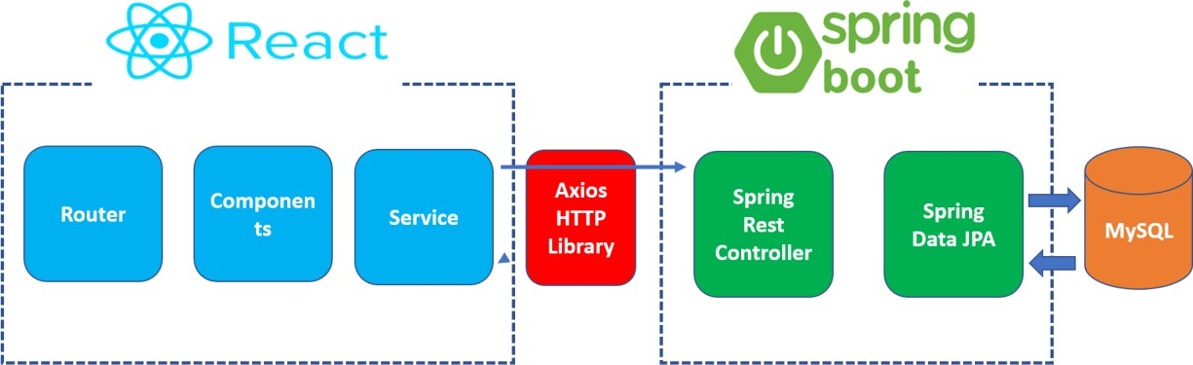

**3.3.1 REACT WORKS:**

It is working on the basis of client server architecture. Client side developing a react application and server side creating a Spring Boot application. Spring Boot application basically exposes restful web services and React application consumes restful web service

The project is titled as Calendar Management System. At its front end, the user can view Event’s and other calendar information from the web application.

**3.3.2 SPRINGBOOT + POSTGRESQL & GOOGLE CALENDAR API WORKS:**

Spring Boot exports REST APIs using Spring Web MVC & interacts with Database using Spring JPA

* React Client sends HTTP Requests and retrieves HTTP Responses using axios, shows data on the components. We also use React Router for navigating to pages.
* Database could be MySQL or PostgreSQL.

Most programming languages provide HTTP clients that you can use to make your own HTTP calls to the API. In fact, the official client libraries often use them behind the scenes. You'll have to set your own API key, headers, and other HTTP settings which can be cumbersome, but usually that is a very routine task. Once you write code to make a single API call, you can reuse it for later API calls.

The native HTTP API might provide a better experience. If you have other special needs like logging, HTTP proxies, and asynchronousness, the native HTTP API may be the only option that let you customize Google Calendar's API calls to work the way you need.

In enterprise applications you may want to programmatically access users data without any manual authorization on their part. In Google Workspace domains, the domain administrator can grant to third party applications domain-wide access to its users' data—this is referred as domain-wide delegation of authority. To delegate authority this way, domain administrators can use service accounts with OAuth 2.0.

At the back end, we connect the application using axios to the back end. The db used here is postgresql. Components involved In Spring Boot application are Spring Rest Controller and Spring Data JPA. Spring Rest Controller basically handles http calls like get, post, put and delete and is developed using Spring MVC. Hibernate is the Spring Data JPA used in this project, which is used to reduce a lot of boilerplate code involved in managing a JPA. PostgreSQL is used as a database.

**CHAPTER 4**

# RESULT AND DISCUSSION

Testing is the major quality measures employed during the software development. After the coding phase, computer programs available are executed for testing purpose. Testing not only has to uncover errors introduced during coding, but also locates errors committed during the previous phase. Thus the aim of testing is to uncover requirements, design or coding errors in the program.

• Testing is a process of executing a program with the intention of finding an error.

• A good test case is one that has a highest probability of finding an as yet undiscovered

error.

• A successful test is one that uncovers an as yet undiscovered error.

Our objective is to design tests that systematically uncover different classes of errors and to do so with minimum amount of time and effort. Testing demonstrate that software functions appear to be working according to specification, that performance requirements appears to have been met. Data collected as testing is conducted provide a good indication of software reliability and some indication of software quality as a whole. But there is one thing that testing cannot do: Testing cannot show the absence of defects it can only show that software defects as present.

**4.1 OUTPUTS**

**GOOGLE CALENDAR.**

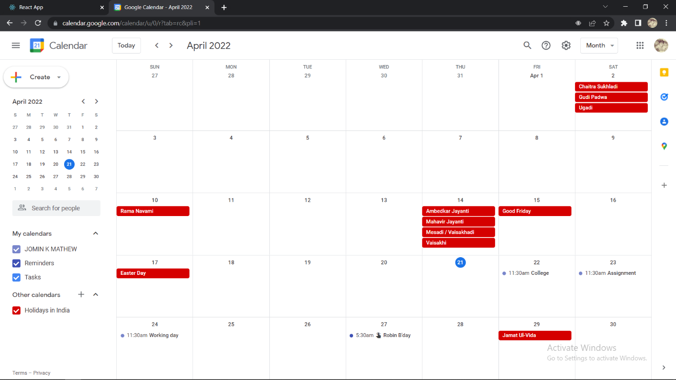

Figure 4.1.1

**STARTING APP.**

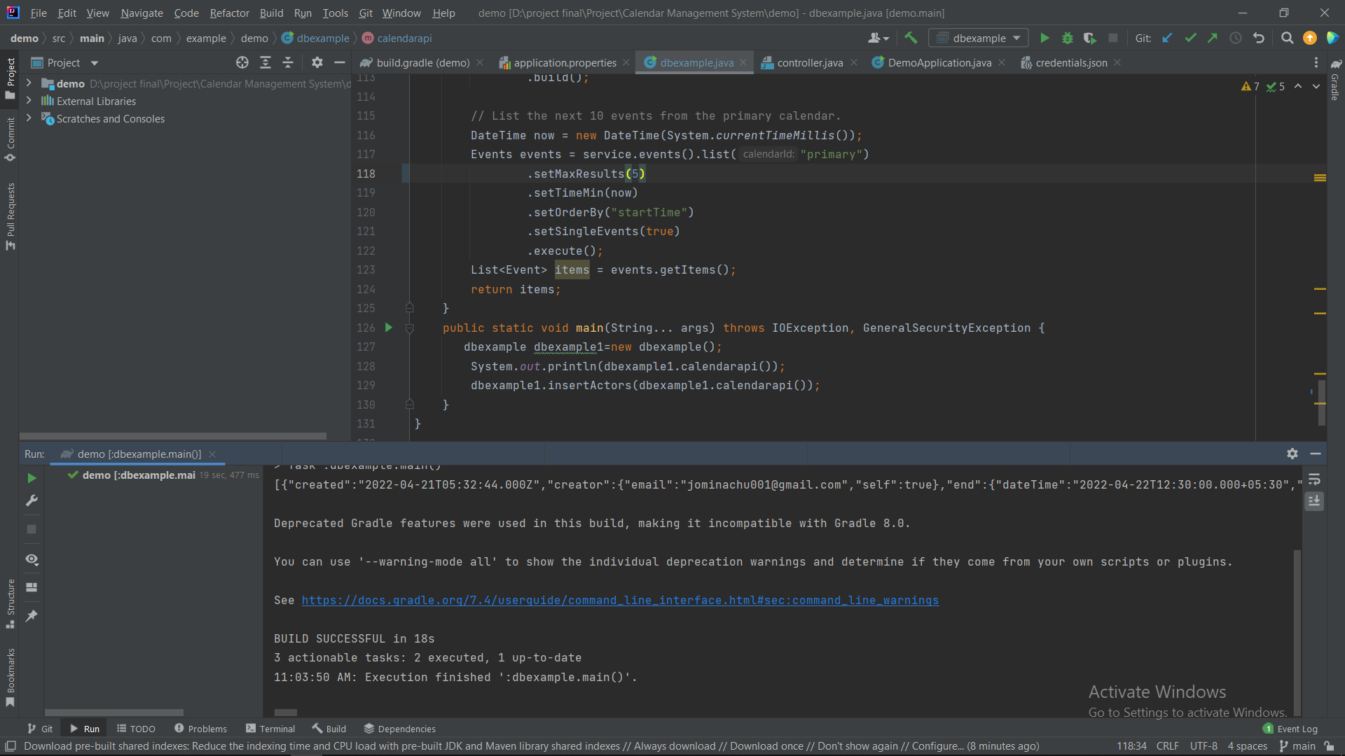

Figure 4.1.2

**DATABASE.**

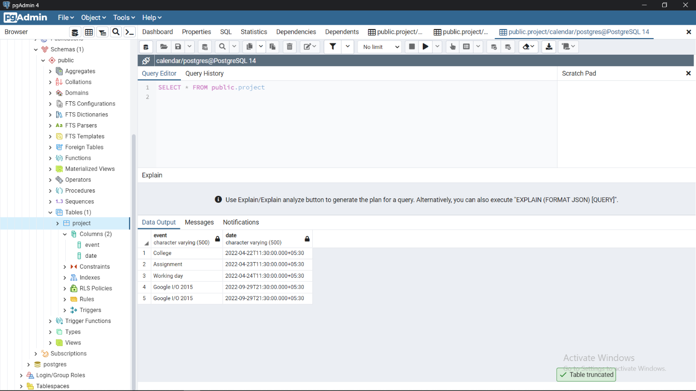

Figure 4.1.3

**DISPLAYING EVENTS.**

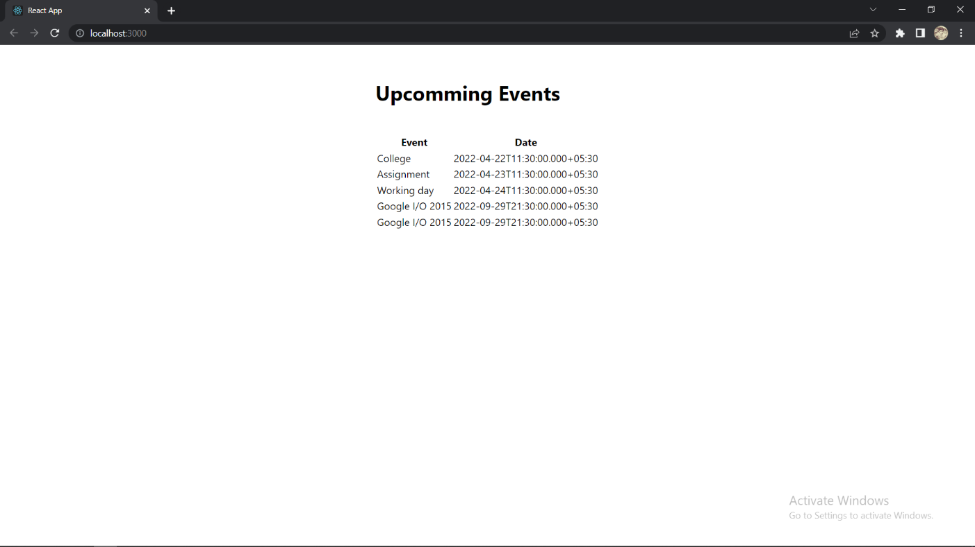

Figure 4.1.4

**CHAPTER 5**

# CONCLUSION

A centralized calendar management system developed using springboot , reactjs and google calendar api. By creating this system we incorporated various kinds of calendars including cloud types and could store them in a database and hence retrieved the details of each events as in a single page. Using this system everyone in the organization could see other’s availability and could rearrange events if necessary.

GitHub link:https://github.com/Calendar-Management-Mini-Project

## 

## 5.1 FUTURE ENHANCEMENT

Future enhancement can be done by incorporating location updation, syncing of events from twitter, facebook etc which is part of our daily life.

**REFERENCES**

[1] P. Hosein and S. Boodhoo, “Event scheduling with soft constraints and on-demand re-optimization,” in 2016 IEEE International Conference on Knowledge Engineering and Applications (ICKEA), Sept 2016, pp. 62– 66.

[2] P. Capek, W. Grey, P. Moskowitz, C. Pickover, and D. Shi, “Event scheduling with optimization,” Mar. 11 2008, uS Patent 7,343,312. [Online]. Available: https://www.google.com/patents/US7343312

[3] R. Zhang, O. Brdiczka, V. Bellotti, and J. Shen, “Method and apparatus for automatically managing user activities using contextual information,” Mar. 6 2014, uS Patent App. 13/599,750. [Online]. Available: https://www.google.com/patents/US20140067455

[4] J. Alford, P. Arellanes, J. George, and M. Molander, “Managing flexible events within an electronic calendar,” Apr. 20 2010, uS Patent 7,703,048. [Online]. Available: <https://www.google.com/patents/US7703048>

[5] P. M. Berry, M. Gervasio, B. Peintner, and N. Yorke-Smith, “Ptime: Personalized assistance for calendaring,” ACM Transactions on Intelligent Systems and Technology (TIST), vol. 2, no. 4, p. 40, 2011.

[6] Microsoft, “Using the calendar in outlook.com,” http://windows.microsoft.com/en-us/windows/outlook/calendar-usecalendar, (Accessed on 04/07/2016).

[7] J. Vincent, “Meeting scheduler with alternative listing,” Sep. 17 1991, uS Patent 5,050,077. [Online]. Available: <https://www.google.com/patents/US5050077>

[8] D. Conmy and J. Banks-Binici, “Electronic calendar with group scheduling and automated scheduling techniques for coordinating conflicting schedules,” Aug. 8 2000, uS Patent 6,101,480. [Online]. Available: <https://www.google.com/patents/US6101480>

[9] D. Conmy, S. Beckhardt, J. Banks-Binici, and R. Slapikoff, “Electronic calendar with group scheduling and storage of user and resource profiles,” Jul. 25 2006, uS Patent 7,082,402. [Online]. Available: <https://www.google.com/patents/US7082402>

[10] B. Cragun and P. Day, “Method and meeting scheduler for automated meeting insertion and rescheduling for busy calendars,” Oct. 16 2007, uS Patent 7,283,970. [Online]. Available: https://www.google.com/patents/US7283970

[11] Web Development using ReactJS, Sanchit Aggarwal, 2018 March

[12] ReactJS Essesntials, Alex Bush, August 2015.

[13] An Open Source JavaScript Libraryfor Front-end Development, Naimul Islam Naim, 30 May 2017

[14] The Spring Framework:An Open Source JavaPlatform for Developing Robust Java Applications, Dashrath Mane, Ketaki Chitnis, Namrata Ojha, IndiInternational Journal of Innovative Technology and Exploring Engineering (IJITEE), 2013

[15] REST API vs GraphQL - A literature andexperimental study, Tobias Andersson and Håkan Reinholdsson, 2021

[16] Wikipedia.org,'React(JavaScriptLibrary)'.Accessible:<https://en.wikipedia.org/wiki/React_> (JavaScript_library).

[17] ReactJS.org,’ ReactJS official'. [Online]. Available: [http://www.ReactJs.org](http://www.reactjs.org/).